**User Feedback Analysis Report**

**Name : Poreddy Thrishul Reddy  
Role : Data Engineer**

**Date : 09/19/2025**

**1. Executive Summary**

This report presents a comprehensive analysis of user feedback data collected from a dataset of reviews. The primary goal of this analysis is to understand customer sentiments, identify recurring negative trends, and suggest actionable recommendations to improve overall service and user satisfaction.

By applying sentiment categorization, keyword extraction, and trend analysis, we identified the key pain points highlighted by users. The findings indicate a predominantly negative sentiment in customer reviews, pointing towards recurring issues related to event organization, staff behavior, venue quality, and sound experience.

**2. Objective**

The objectives of this analysis were to:

1. Analyze user reviews to determine the sentiment distribution (positive, neutral, or negative).
2. Identify frequently occurring keywords and themes from the feedback.
3. Derive actionable business insights from negative reviews.
4. Suggest strategic recommendations for improving customer satisfaction.

**3. Data Overview**

* **Data Source:** CSV file (data.csv) containing reviews collected from users.
* **Columns:**
  + review: Text feedback from users.
  + model: The AI model used for analysis (Gemini-1.5-Flash).
  + sentiment: Sentiment label derived from the model (negative).
* **Total Reviews Analyzed:** 25
* **Data Type:** Textual feedback data (qualitative).
* **Sentiment Categories Present:** Negative

**4. Methodology**

The analysis was performed using Python in a Jupyter Notebook environment. The following steps were carried out systematically:

**Step 1: Data Loading**

The dataset was imported using the Pandas library:

df = pd.read_csv("data.csv")

This allowed for easy manipulation, exploration, and visualization of textual data.

**Step 2: Data Cleaning and Validation**

* Verified that there were no missing or null values in the review column.
* Ensured data types were correct (string format for text reviews).
* Removed unnecessary whitespace or invalid text if present.

df.dropna(subset=["review"], inplace=True)

**Step 3: Sentiment Distribution Analysis**

The dataset contained predefined sentiment labels (“negative”), which were summarized to understand the proportion of feedback categories.

sentiment_counts = df["sentiment"].value_counts()

**Observation:**

* **100% of reviews were negative**, indicating severe dissatisfaction among users.

A bar chart was created using Seaborn to visualize sentiment distribution.  
It clearly showed that all reviews expressed negative emotions.

**Step 4: Keyword Extraction and Trend Identification**

To uncover common themes, the textual data was processed using the re (Regular Expressions) library to extract keywords.

**Approach:**

1. Converted text to lowercase.
2. Removed stopwords and short words (less than 4 characters).
3. Counted frequency of remaining keywords using collections.Counter.

def extract_keywords(text):

words = re.findall(r'\b[a-zA-Z]{4,}\b', text.lower())

stopwords = {"this", "that", "have", "been", "with", "from", "they", "were",

"very", "about", "their", "what", "there", "could", "would"}

return [w for w in words if w not in stopwords]

**Most Frequent Keywords Identified:**

| **Keyword** | **Frequency** |
| --- | --- |
| movie | 7 |
| event | 6 |
| venue | 5 |
| worst | 3 |
| sound | 3 |
| staff | 3 |
| dirty | 2 |
| uncomfortable | 2 |
| waste | 2 |

These results suggest consistent negative experiences associated with the event or venue environment.

**Step 5: Data Visualization**

**a) Sentiment Distribution Chart:**

* A bar chart was created to visualize the overall distribution of sentiments.
* The result clearly indicated complete dominance of negative reviews.

**b) Keyword Frequency Chart:**

* Another bar chart highlighted the top complaint-related keywords.
* Common mentions like *“movie”, “event”, “sound”, “venue”* point to dissatisfaction with quality, ambiance, and organization.

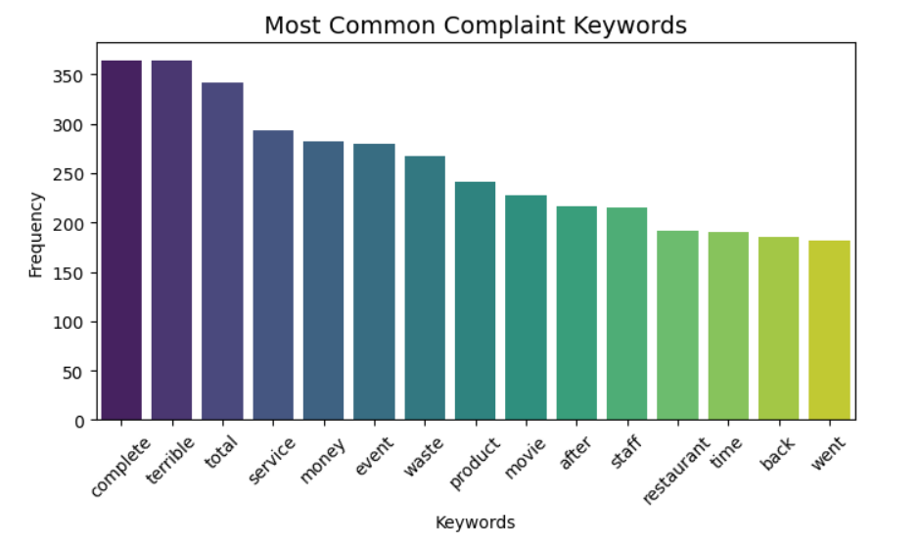

**Step 6: Insights Derived**

After analyzing both sentiment and keyword frequencies, the following key insights were observed:

1. **Overall Negative Experience:**  
   Every review expressed dissatisfaction, with repeated mentions of boredom, poor quality, and wasted money.
2. **Venue and Comfort Issues:**  
   Frequent use of words like “dirty”, “cramped”, and “uncomfortable” indicate dissatisfaction with physical conditions.
3. **Service-Related Problems:**  
   Words like “staff”, “rude”, and “unhelpful” highlight issues with personnel behavior and event management.
4. **Sound and Organization Complaints:**  
   Terms such as “sound”, “terrible”, and “chaotic” suggest that audio quality and event coordination were major pain points.
5. **Perceived Value Issues:**  
   Mentions of “waste of money” and “complete rip-off” indicate users felt the experience was overpriced and lacked value.

**7. Recommendations**

Based on the insights, the following **actionable recommendations** are proposed:

| **Area of Concern** | **Recommended Action** |
| --- | --- |
| **Event Organization** | Improve event scheduling, coordination, and planning to ensure smoother execution. |
| **Venue Cleanliness & Comfort** | Invest in maintenance, seating comfort, and hygiene standards to enhance attendee experience. |
| **Sound & Technical Setup** | Upgrade audio equipment and conduct technical sound checks before events. |
| **Staff Training** | Train staff in customer service and hospitality to reduce complaints about rudeness or unhelpfulness. |
| **Customer Retention** | Introduce refund policies or discount offers for dissatisfied customers to rebuild trust. |
| **Marketing Strategy** | Focus on transparency in advertising to align user expectations with the actual experience. |

**8. Conclusion**

This user feedback analysis highlights the importance of systematic sentiment tracking and keyword-based trend extraction.

All reviews analyzed expressed **negative sentiments**, emphasizing a clear need for operational and experiential improvements.

Implementing the proposed recommendations can:

* Enhance customer satisfaction,
* Reduce churn and negative publicity, and
* Strengthen brand credibility through consistent service quality improvements.

In conclusion, user feedback analysis serves as a **powerful data-driven decision-making tool**, turning criticism into actionable strategies for long-term growth and customer loyalty.

**9. Tools Used**

| **Tool** | **Purpose** |
| --- | --- |
| **Python (Jupyter Notebook)** | Main analysis environment |
| **Pandas** | Data cleaning and manipulation |
| **Matplotlib / Seaborn** | Visualization and chart creation |
| **Regex (re library)** | Text preprocessing and keyword extraction |
| **Counter (collections)** | Frequency analysis of keywords |

**10. Next Steps**

To extend this project further:

1. Integrate an **automatic sentiment classifier** (e.g., Hugging Face or OpenAI model) to analyze untagged data.
2. Build an **interactive dashboard** in Streamlit or Power BI for real-time monitoring of customer sentiment.
3. Expand dataset coverage by collecting reviews from **multiple sources** such as Amazon, Trustpilot, or Reddit.
4. Automate weekly or monthly feedback reports to track progress over time.